**EXPERIMENT NO. 4**

**Aim:** To Implement media queries to make responsive web pages.

**Theory:**The Media query in CSS is used to create a responsive web design. It means that the view of a web page differs from system to system based on screen or media types. The breakpoint specifies for what device-width size, the content is just starting to break or deform. The CSS rule introduced different style rules for different media types.

Media queries can be used to check many things:

* width and height of the viewport
* width and height of the device
* Orientation
* Resolution.

A media query consists of a media type that can contain one or more expressions that can be either true or false. The query’s result is true if the specified media matches the type of device the document is displayed on. If the media query is true then a style sheet is applied.

**Syntax:**

@media not | only mediatype and (expression) {

// Code content

}

**Media Types in CSS:**

There are many types of media types which are listed below:

* All:- It is used for all media devices.
* Print:- It is used for printers.
* Screen:- Used for computer screens, smartphones, etc.
* Speech:- Used for screen readers that read the screen aloud.

**Features of Media query:**

There are many features of media query which are listed below:

* Color:- The number of bits per color component for the output device.
* Grid:- Checks whether the device is grid or bitmap.
* Height :- The viewport height.
* aspect ratio:- The ratio between the width and height of the viewport.
* Color-index:- The number of colors the device can display.
* Max-resolution:- The number of bits per color on a monochrome device.

CODE:

CSS CODE:

@media only screen and (orientation: landscape) {

.content {

max-height: calc(90vh - 80px);

}

.content::before {

content:"";

float: right;

width: 15%;

height: 100%;

margin: auto 0;

}

}

@media only screen and (max-width: 600px){

.content{

min-height: 100%;

overflow-y: scroll;

}

.content::before {

visibility: hidden;

}

.main{content:"";

float: right;

width: 15%;

height: 100%;

margin: auto 0;

}

}

HTML CODE:

<!DOCTYPE html>

<html lang="en">

<head>

    <meta charset="UTF-8">

    <meta name="viewport" content="width=device-width, initial-scale=1.0">

    <title>Document</title>

    <link rel="stylesheet" href="style.css">

</head>

<body>

    <header>

     <div class="main">

         <div class="logo">

            <img src="images/Frame 1.png" alt="" id="logo">

         </div>

     <ul>

         <li class="active"><a href="#hero">Home</a></li>

         <li><a href="#aboutUs">About us</a></li>

         <li><a href="#Services">Services</a></li>

         <li><a href="#Contactus">Contact Us</a></li>

         <li><button class="login">login</button></li>

         <li><button class="SignUp">Sign Up</button></li>

     </ul>

     </div>

     <div class="hero">

        <h1>WE ARE...</h1>

        <h2>an event , design , planning and creative consulting company specializing in customised experience for our clients and their guests</h2>

        <div>

            <select name="Location" id="" class="optlocation">

                <option value="All">All LOCATIONS</option>

                <option value="Navi Mumbai">Navi Mumbai</option>

                <option value="Mumbai">Mumbai</option>

                <option value="Pune">Pune</option>

                <option value="Nagpur">Nagpur</option>

            </select>

            <select name="CAtegory" id="" class="optcategory">

                <option value="All Categories">All CATEGORIES</option>

                <option value="Birthday">Birthday</option>

                <option value="Wedding">Wedding</option>

                <option value="Party">Party</option>

                <option value="Funeral">Funeral</option>

            </select>

        </div>

        <div class="Explorebutton">

            <button class="Explore">

                Explore

            </button>

        </div>

    </header>

<div class="aboutUs" id="aboutUs">

    <h1>About Us</h1>

    <p>Lorem ipsum dolor sit amet consectetur, adipisicing elit. Omnis ea, earum, quod voluptatum, exercitationem blanditiis provident fugit illo pariatur quos fugiat dicta cumque quas sint optio porro adipisci expedita? Sunt.</p>

    <div class="bt">

        <button id="Exploremore">Explore More</button>

    </div>

</div>

<div class="Services" id="Services">

    <div class="container">

        <div class="box">

            <img src="" alt="">

        </div>

        <div class="box">

            <img src="" alt="">

        </div>

        <div class="box">

            <img src="" alt="">

        </div>

    </div>

    <div class="Contactus" id="Contactus">

    <h1>Contact Us</h1>

    </div>

</div>

<section class="footer">

    <div class="box-container">

        <div class="boxf">

            <h3>quick links</h3>

            <a href="">Home</a>

            <a href="">About us</a>

            <a href="">Contact us</a>

            <a href="">LOGIN</a>

            <a href="">SIGN UP</a>

            <a href="">Explore</a>

        </div>

        <div class="boxf">

        <h3>Conatct Details</h3>

        <a href="">+12345678</a>

        <a href="">+12345678 </a>

        <a href="">abc@gmail.com</a>

        <a href="">abc@gmail.com</a>

        <a href="">abc@gmail.com</a>

        <a href="">Navi Mumbai, New Panvel</a>

        </div>

    </div>

</section>

</body>

</html>

**OUTPUT:**

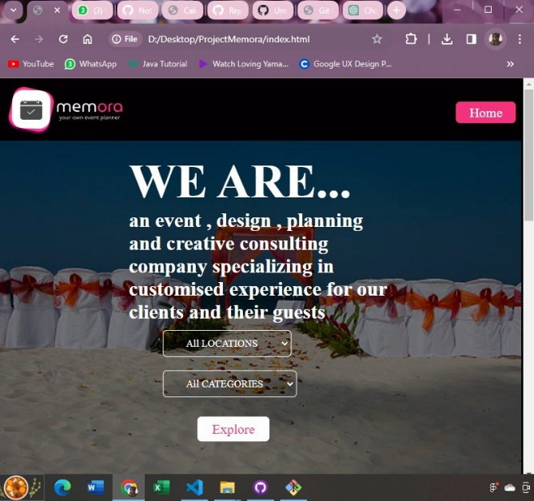

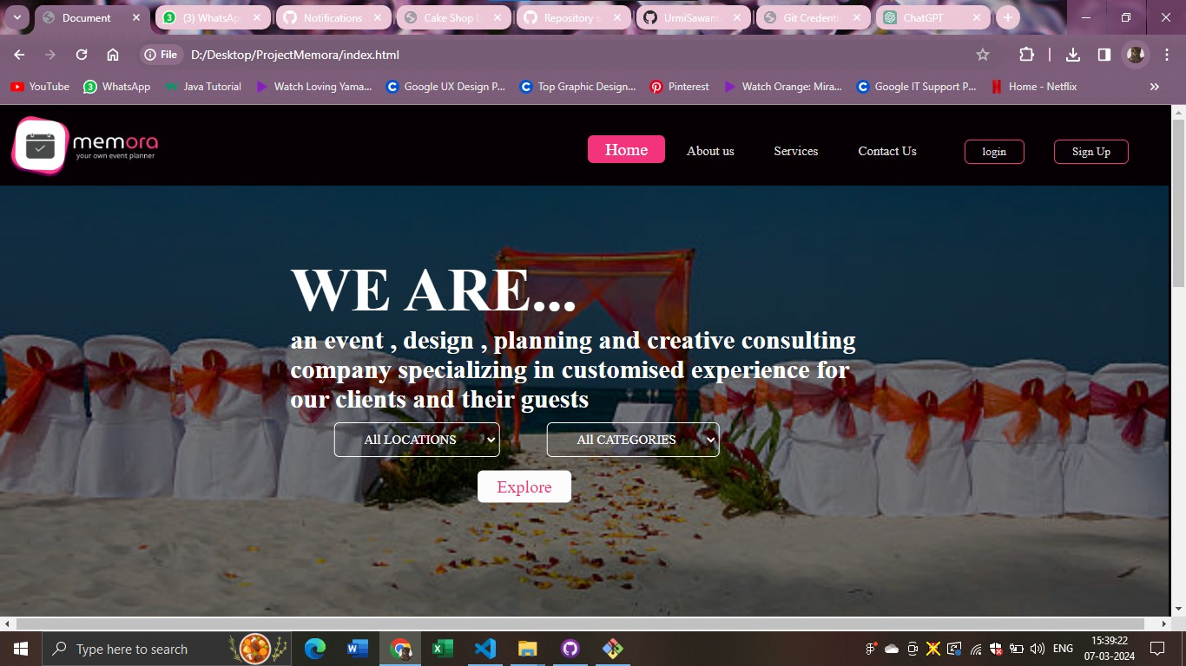

**Conclusion:** Thus we have successfully implemented media queries in our project by which as the screen gets smaller the website adjusts to that size.